**Sandeepa Y.V.P – IT24100834**

**PS LAB 06**

**Exercise**

1. A train arrives at a station uniformly between 8:00 a.m. and 8:40 a.m. Let the random variable X represent the number of minutes the train arrives after 8:00 a.m. What is the probability that the train arrives between 8:10 a.m. and 8:25 a.m.?

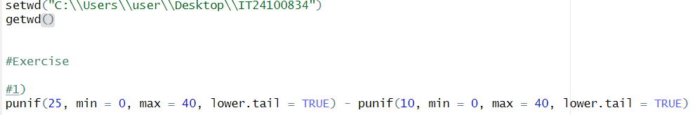

2. The time (in hours) to complete a software update is exponentially distributed with rate λ = 1/3. Find the probability that an update will take at most 2 hours.

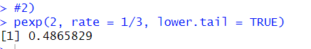

3. Suppose IQ scores are normally distributed with a mean of 100 and a standard deviation of 15.

i. What is the probability that a randomly selected person has an IQ above 130?

ii. What IQ score represents the 95th percentile?

